**Tables and forms in HTML**

HTML forms can be used for:



1Q. What does the action attribute in an HTML form do?

Specifies where to send the form data after the form is submitted.

2Q. What is a semantic HTML element?

An element that clearly describes it’s meaning to both the browser and the developer.

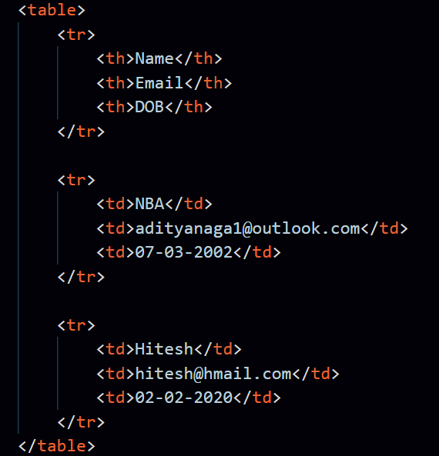

1. Inside <table></table> tags we write the HTML markup language for table.
2. tr stands for table row.
3. th stands for table head.
4. td stands for table data.

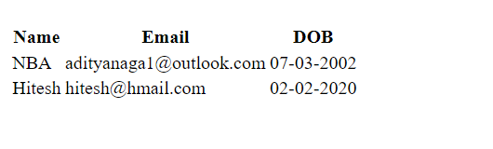

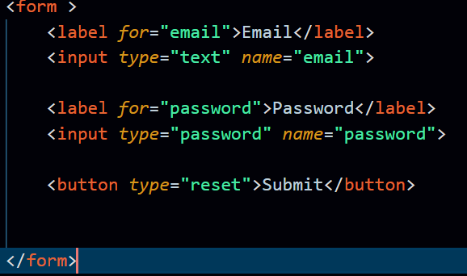

1. **label + tab** => **<label for=””></label>** . In label tag, we mention the name of the input we are taking from the user.
2. **input + tab** => **<input type=”” name=””>** . In input tag, we mention the type of input that we are expecting to take from the user, for ex: password, text etc.
3. **button + tab** => **<button type=”reset”></button**> . In button tag, name of the button and the type of the button (for ex: submit, reset etc.) are mentioned.

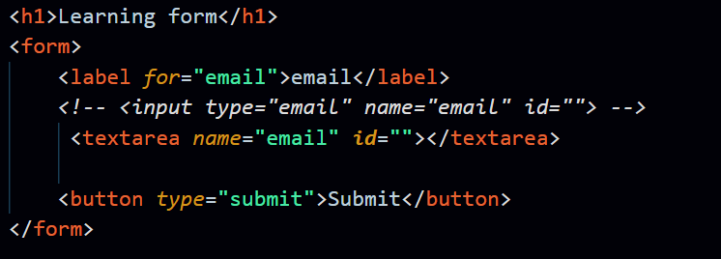

1. textarea tag is used when we want to take big text inputs.

